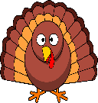 Ms. Laursen’s Newsletter 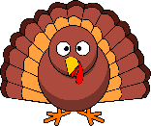
November 16, 2017

Dates to Remember
Thursday is our Library Day!
November 21 – Assembly on Science/Magic in the morning
November 22, 23, 24 – No School

Classroom News
Exploratory next week – Gym

Our new High Frequency words this week are: as, has, want. This week we learned all about the letters H and W, the sounds they make, and words that begin and end with their sounds. We also looked at American Symbols, landforms, the water cycle and the environment. In math, we looked at the teen numbers 13 – 16 and different ways we can show each number, for example with shapes, tally marks, and coins.

This week our Backpack Bear book was called At the Library. Please remember to practice reading with your child and sign their log sheet in their folder. Your child can also get out the previous Backpack Bear books to read for practice.

I sent home your student’s home project for our Social Studies VIP and Me event on December 5. If you have not already sent this back, please work with your child on it at home and return it to me no later than November 20th.

Thank you to the Bezemek family for your donation to our classroom for Popcorn Friday this month! If anyone else is interested in donating for Popcorn Friday, please let me know.

We go out for recess every day unless it is raining or below 0. Please make sure your child has a warm coat, hat, and gloves to keep them warm while we are out. If you need any of these items please let me know as we have extras to share at the school.

