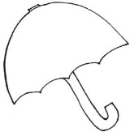 Ms. Laursen’s Newsletter 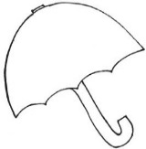
April 26, 2018

Dates to Remember
Thursday is our Library Day!
May 2 – ACES Day (All Kids Exercise Simultaneously) 1:00 – 2:30
May 11 – Octagon Barn Field Trip 8:30 – 2:30

Classroom News
Exploratory next week – Gym

This week in Reading, we reviewed the digraphs /th/, /sh/, and /ch/ and were introduced to /wh/. The class is getting very good at spotting these in our daily reading! This week we took a look at Fish in the Animal Kingdom and learned what characteristic they have that makes them unique. We met a fish named Swimmy who taught us more about perseverance and why it is important to never give up. Our new HF Words this week were: when, where, no, so. Our new Backpack Bear books this week are Fish and Me and Tin Man Sits. Please read these at home with your child and sign the Reading Log in their folder.

In Math, we have been discussing Perimeter and Area and how we can measure both with different measuring tools. We also experimented with many different objects and a ramp to see how far objects would roll and what factors might affect that distance such as carpet thickness, shape, and weight. Please continue to work on addition and subtraction problems at home as we still do our timed tests twice a week. The kids have been so awesome at congratulating each other when they pass their time test and encouraging those who haven’t quite made it yet. I love seeing this support of one another in class!

If you still have one of the Lending Library books at home, please send it back in with your child. Thank you!

Tomorrow is the last day to turn in any order forms for our classroom book. Even if you are not planning to buy the book, please send your slip back marked no so we can earn a free book for our classroom! The kids are very excited about their own page they will be contributing and I think it will be great to have our own copy to share in here.

