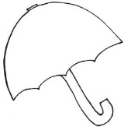 Ms. Laursen’s Newsletter 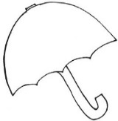
April 19, 2018

Dates to Remember
Thursday is our Library Day!
May 2 – ACES Day (All Kids Exercise Simultaneously)

Classroom News
Exploratory next week – Computers

This week in Reading, we met Tin Man who came to teach us about the short –i. He introduced us to the word families –in, -ick, -ip, and –ig. Our new HF words were too and many. In writing, we looked at writing narratives and persuasive writing as two new ways to share our ideas. We also started to take a look at reptiles and talked about Charles Darwin. Our new Backpack Bear book was called The Big Hit. Please read this at home with your child and sign the Reading Log in their folder.

In Math, we took a look at equal parts by sharing a stack of cubes with our group making sure that everyone had the same amount or equal pieces. We also worked with fractions, length, and height. One thing we are also spending a lot of time on is story problems and working together to “pull the numbers out of the words” to make an equation, which they are getting REALLY good at doing. Please continue to work on addition and subtraction problems at home as we still do our timed tests twice a week.

March is Reading Month has come to an end, so I am going to bring an end to our Classroom Lending Library. If you still have one of the Lending Library books at home, please send it back in with your child. Thank you!

If you have not already, please send in the order form marked “yes” or “no” for our book we are writing, so we can earn a free copy of the book for our classroom! The kids are very excited about their own page they will be contributing and I think it will be great to have our own copy to share in here.

