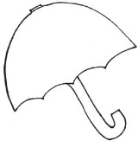 Ms. Laursen’s Newsletter 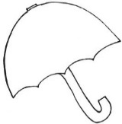
April 12, 2018

Dates to Remember
Thursday is our Library Day!
April 12 – Report Cards Go Home

Classroom News
Exploratory next week – Fine Arts

This week in Reading, we reviewed short –a, -e, and –o words, worked on rhyming words, and practiced our writing skills. We did not have a new Backpack Bear book this week, so please practice the old ones at home to keep your child’s reading skills sharp! We will be making a classroom book where your child will be the “author” of one page. I am sending home a letter/order form for you if you would like to purchase a book. Even if you do not want a book, please check the no box and send the form back so we can earn a free copy of the book for our classroom!

In Math, we worked on strengthening our skills by practicing our addition and subtraction facts, creating equations, and reviewing coins so we will be able to add and subtract money. We took our 2 min subtraction time test yesterday for the first time and you will find it with your child’s finished work along with a blank copy to practice at home. Please continue to work on addition and subtraction problems at home.

March is Reading Month has come to an end, so I am going to bring an end to our Classroom Lending Library. If you still have one of the Lending Library books at home, please send it back in with your child. Thank you!

I sent home a note Monday regarding our new show and tell schedule as well as the schedule itself. If you need another copy or have any questions regarding the new schedule, feel free to contact me.

(See back for upcoming events/dates in Kindergarten!)

